**1.Create VPC with 2 private and 2 public subnets**.

Go to VPC services-🡪 click create vpc.

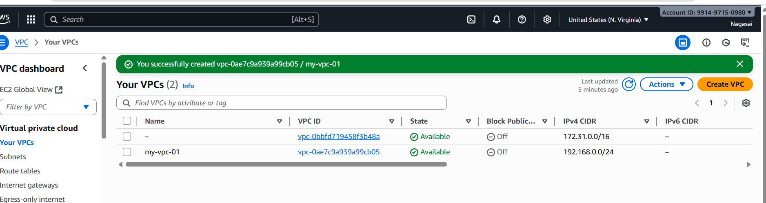

Create 2 public subnet and 2 private subnets

Go to vpc-🡪click on subnet 🡪create subnet-🡪add public subnet1🡪create public subnet.

Also, similarly add 2 private subnet and create subnet.

* **Public Subnet 1 (AZ1)** → 192.168.0.0/28

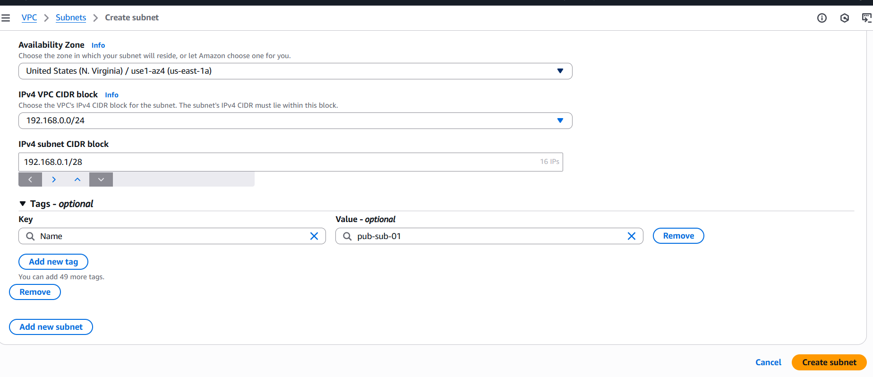

* **Public Subnet 2 (AZ2)** → 192.168.0.1/28

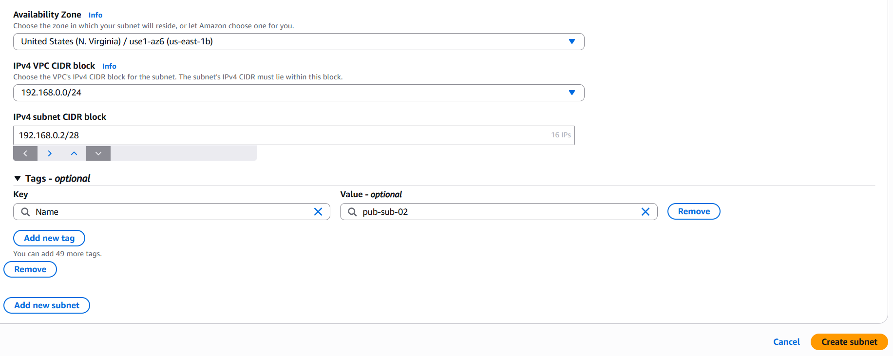

* **Private subnet1 (AZ1)** → 192.168.0.63/28

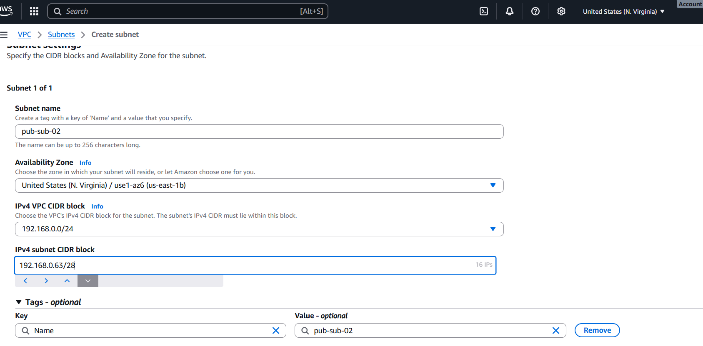

* **Private Subnet 2 (AZ2)** → 192.168.0.128/28

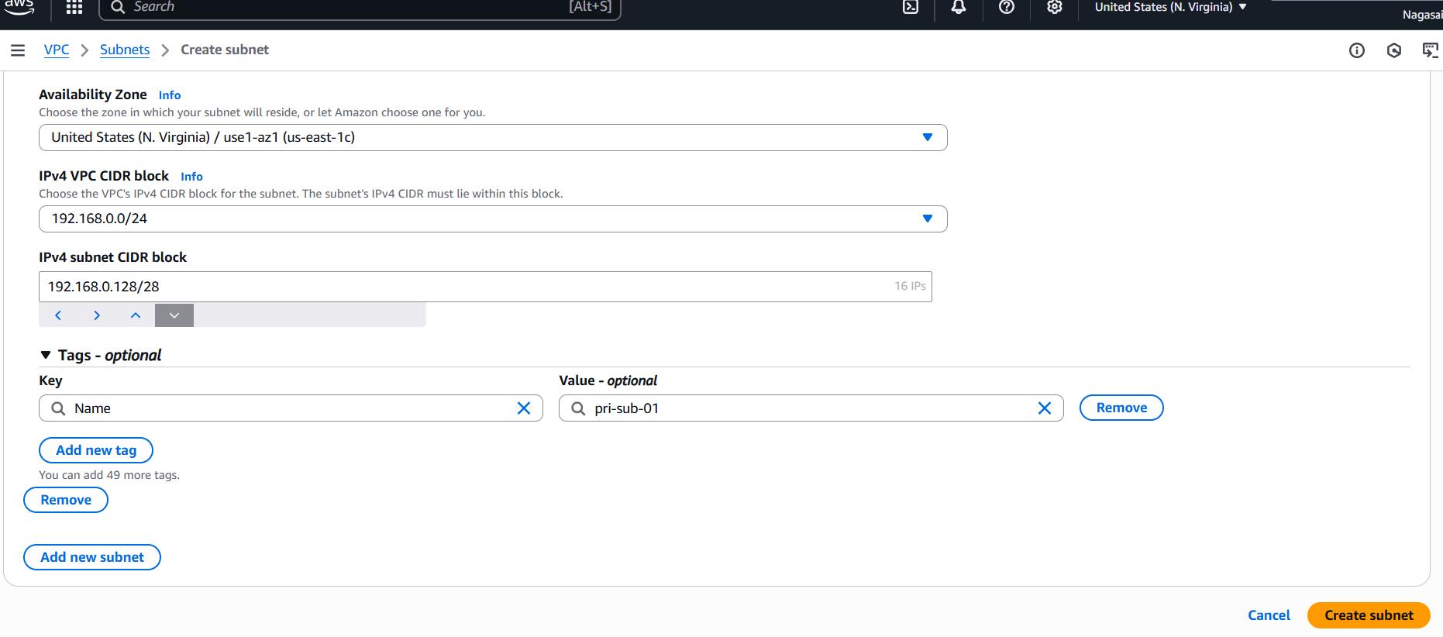

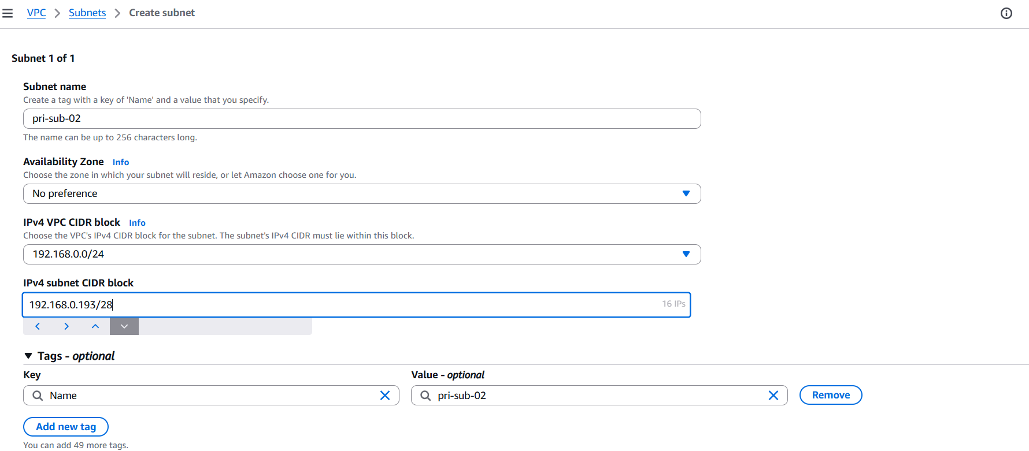

**2.Enable DNS Hostname in VPC.**

Actions → Edit VPC settings

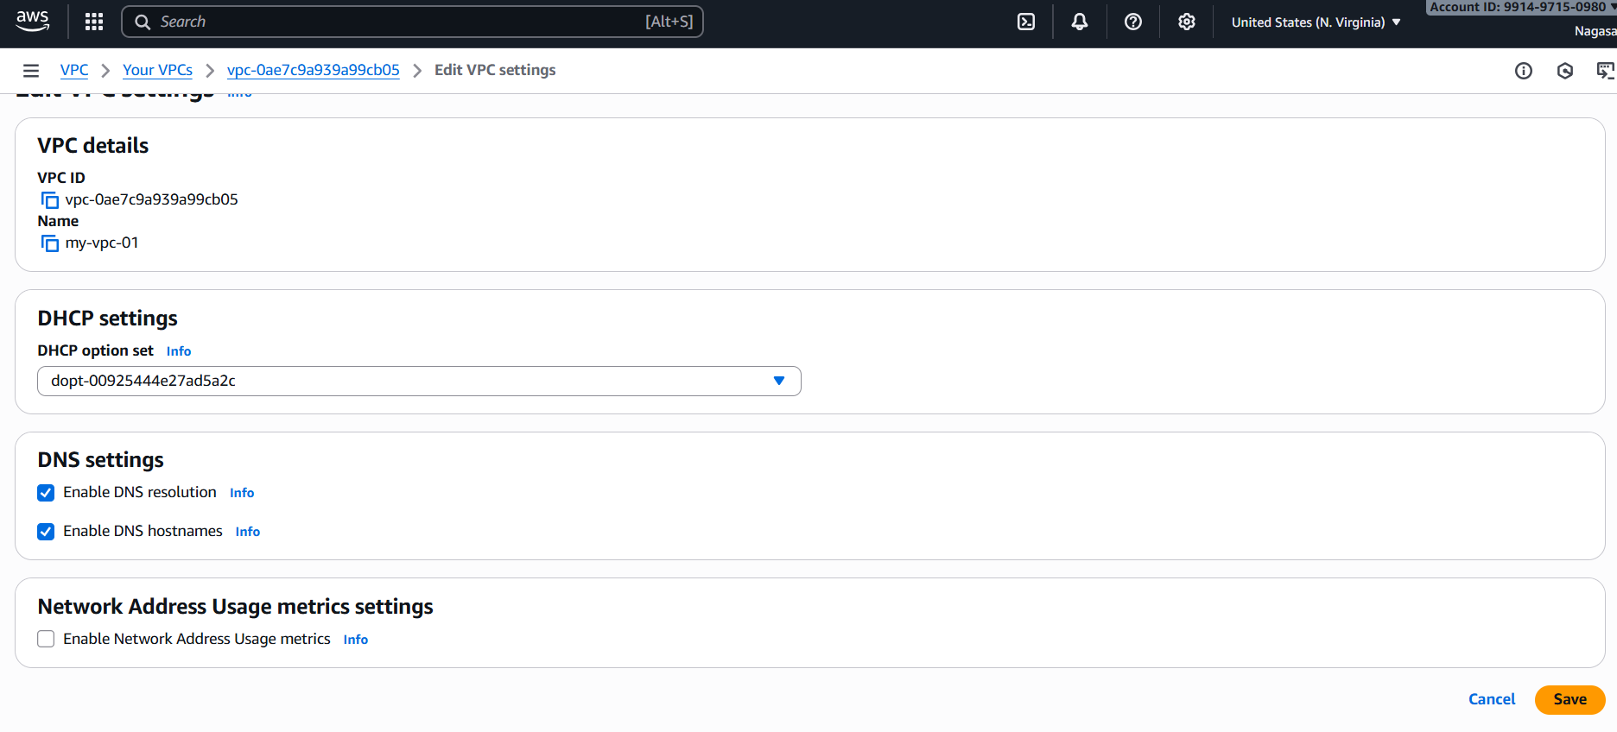

Dns settings-🡪 enable dns hostname.

**3. Enable Auto Assign Public IP in 2 public subnets.**

Go to vpc services 🡪click on subnet🡪edit subnet settings🡪enable auto assign ip settings.

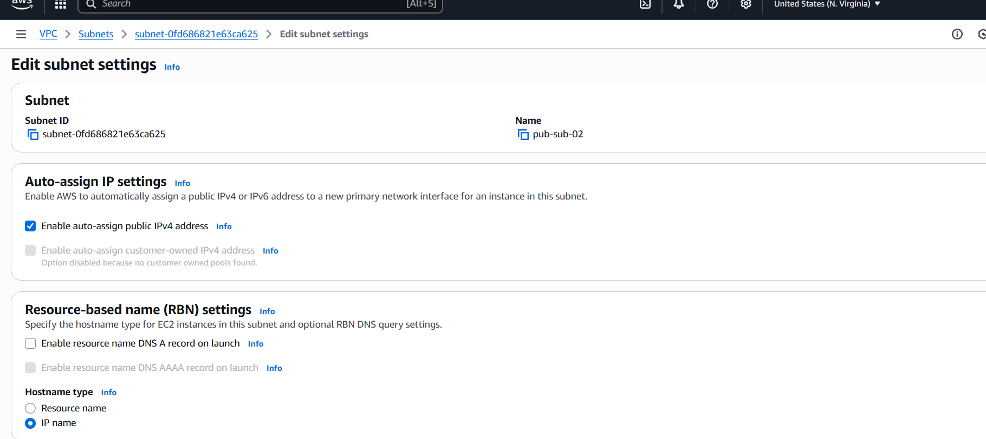

**4. Add 2 private subnets in private route table.**

For that u have to create a route table. Go to route🡪create route table.

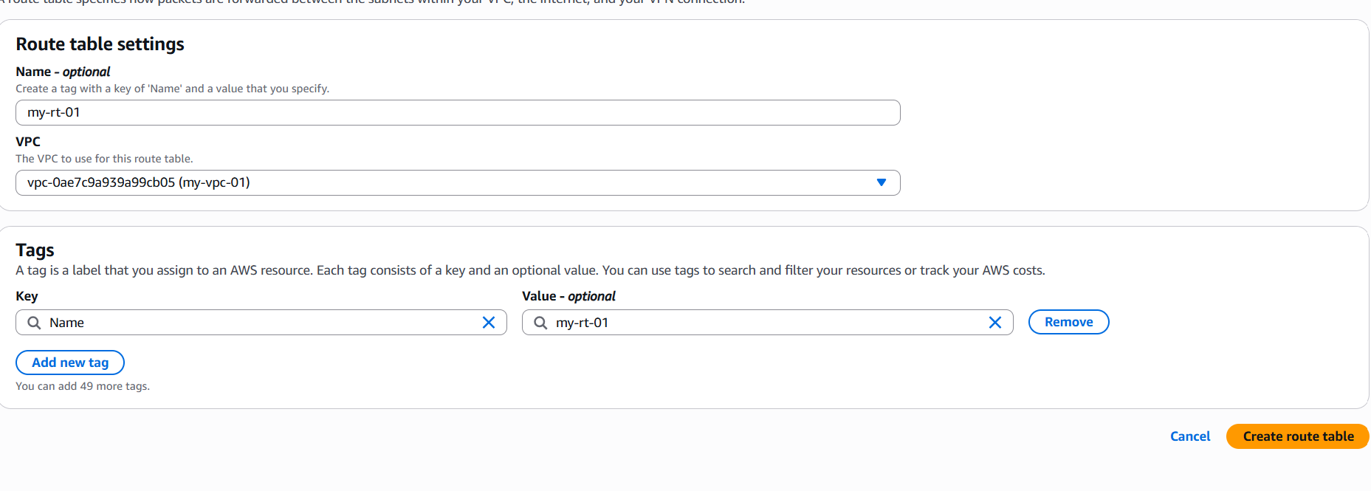

Go to route table -🡪add 2 private subnets 🡪click on edit subnet associations-🡪save associations.

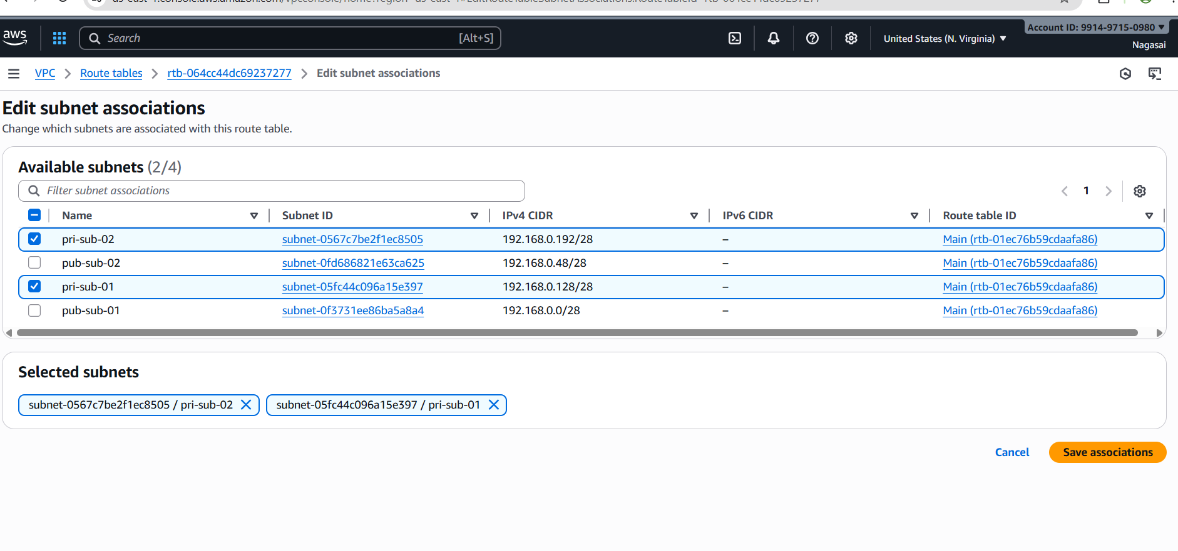

1. **Add 2 public subnets in public route table.**

Also, similarly add 2 public subnets

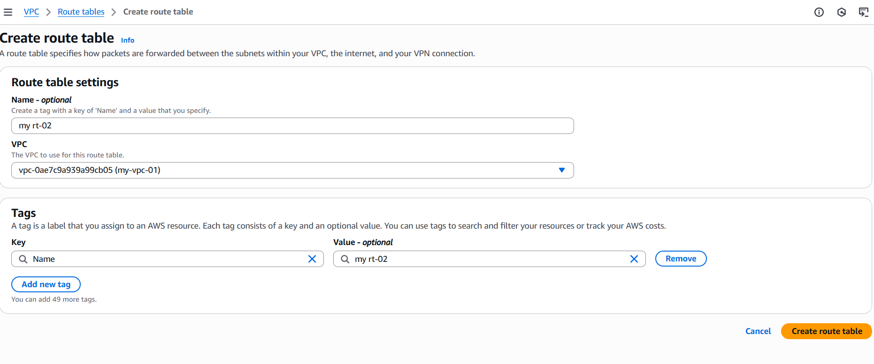

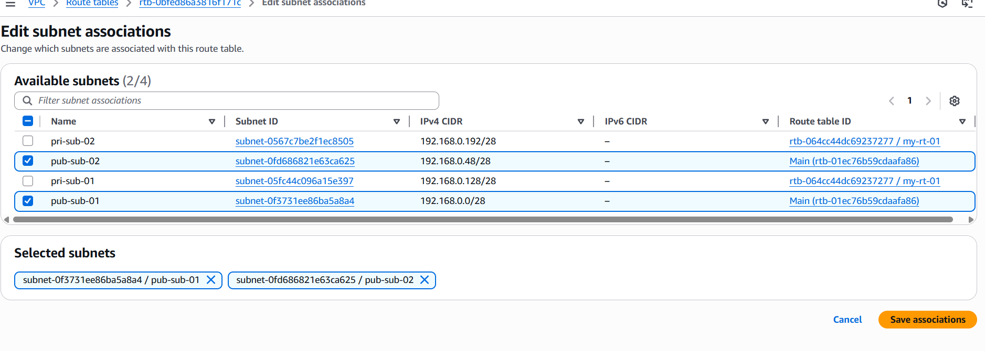

**6.Public route table will have the routes to internet and local**.

We have give the internet access to public route create internet gateway.

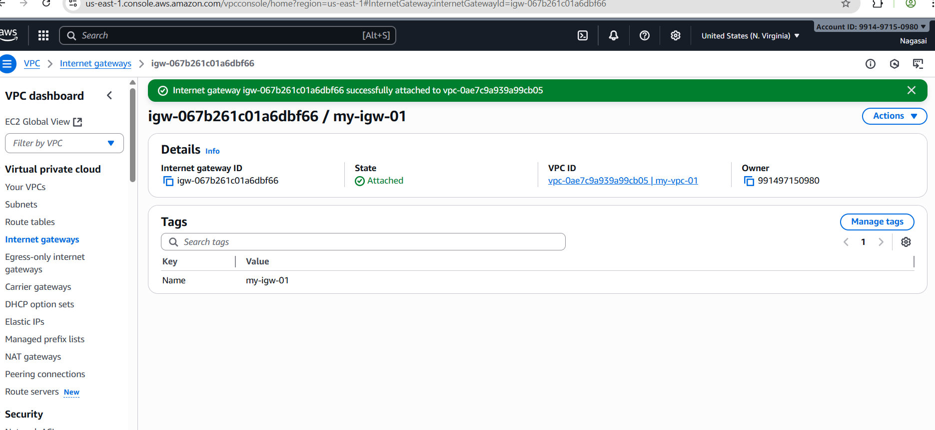

And add internet gateway to private route tables.

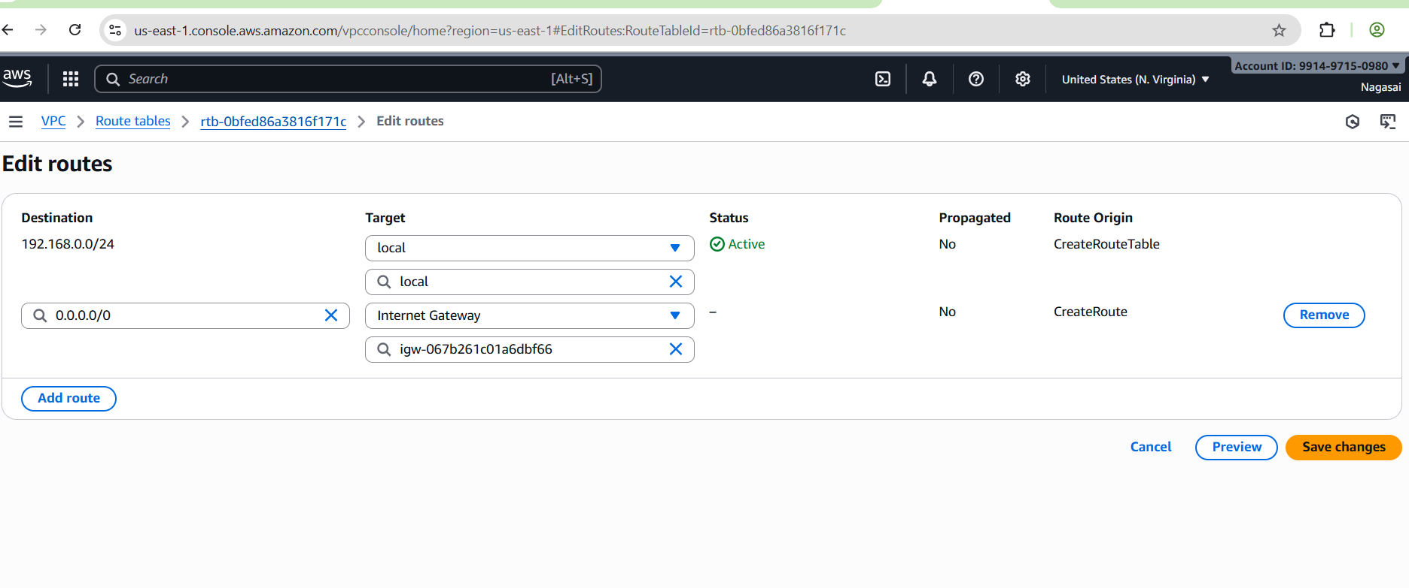

**7.Create EC2 in public subnet with t2.micro and install PHP**.

Go to ec2 services 🡪 add name 🡪select an ami🡪select t2 micro.

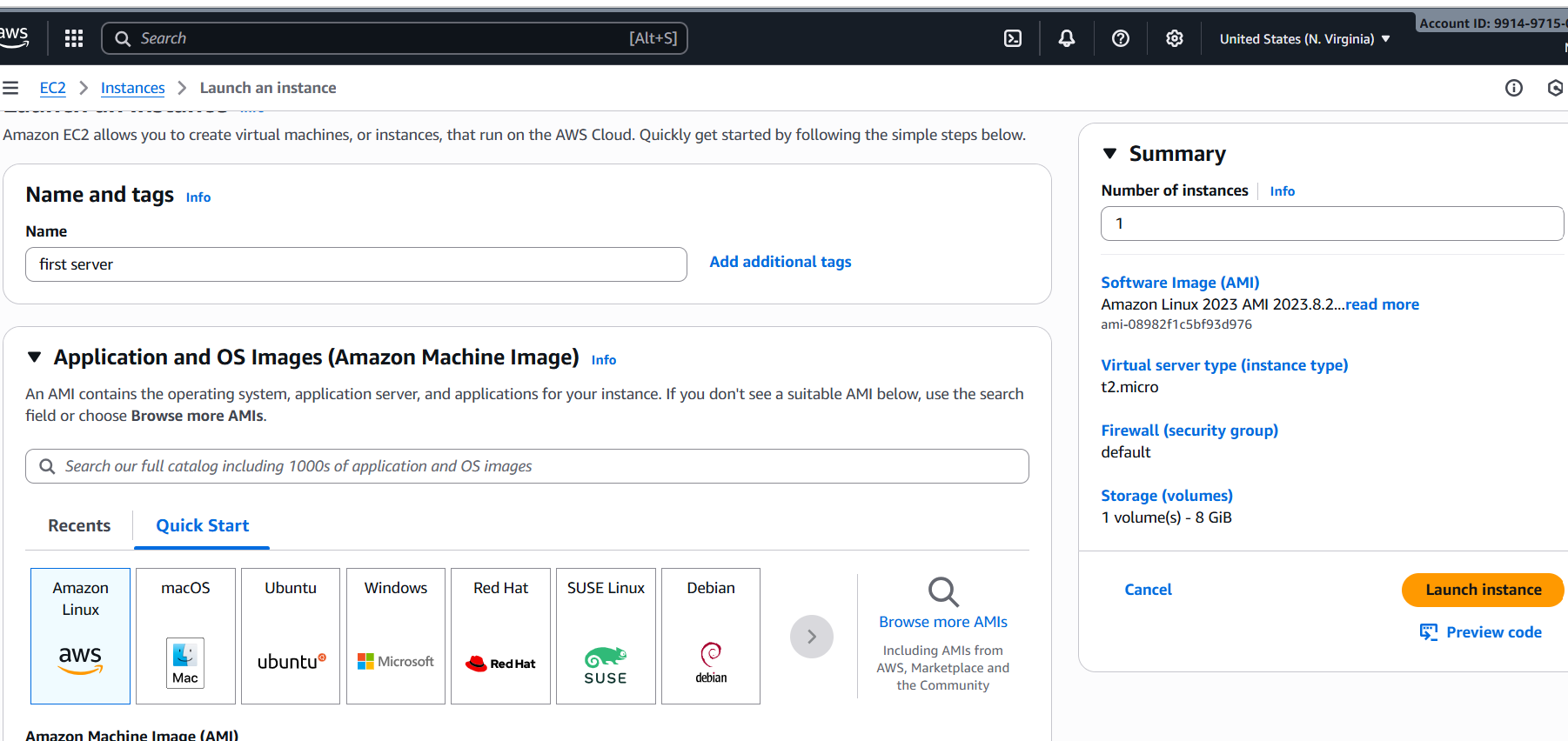

Add existing key pair or create new key pair🡪select vpc🡪add public subnet-🡪 launch instance.

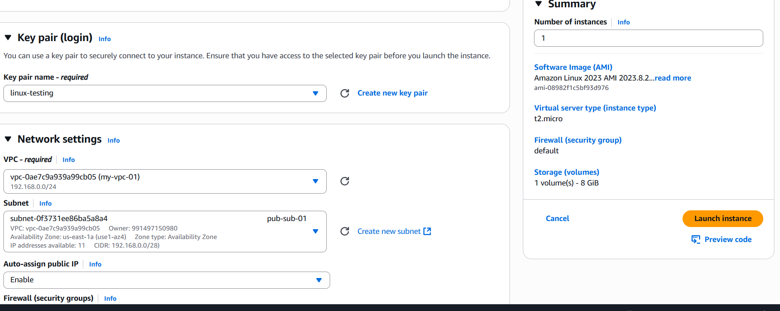

Successfully launch an instance.

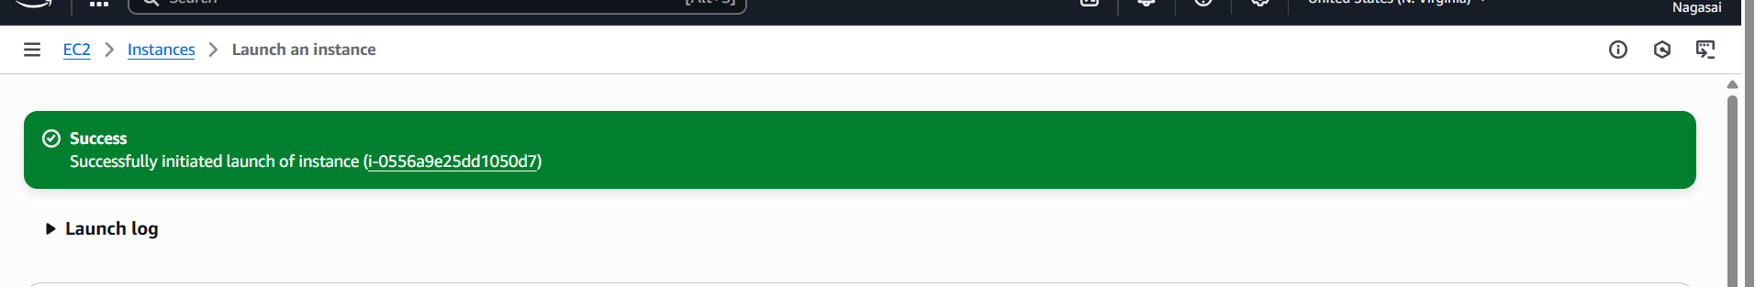

Yum update -y

sudo yum install -y php php-cli php-mysqlnd => use this command for install for PHP

echo "<?php phpinfo(); ?>" | sudo tee /var/www/html/index.php=>

systemctl start httpd

systemctl enable httpd

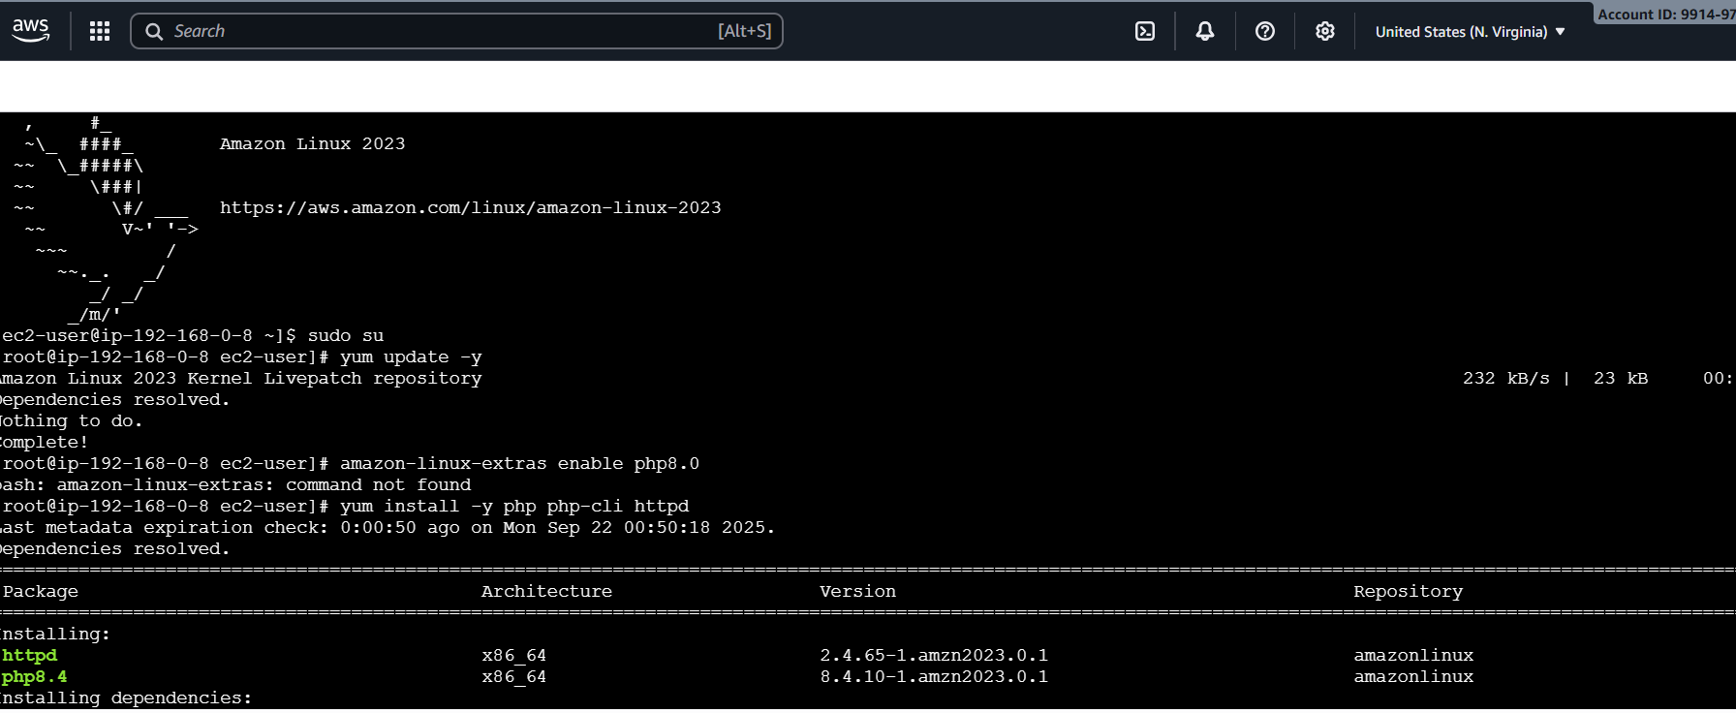

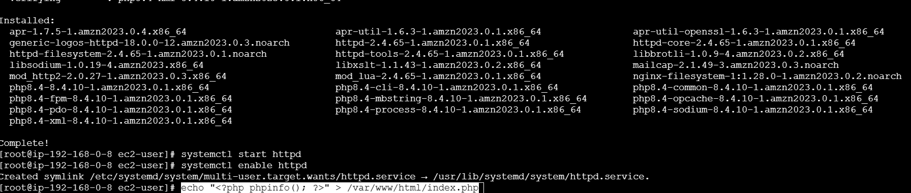

Go to browser and enter https:public ip:80.

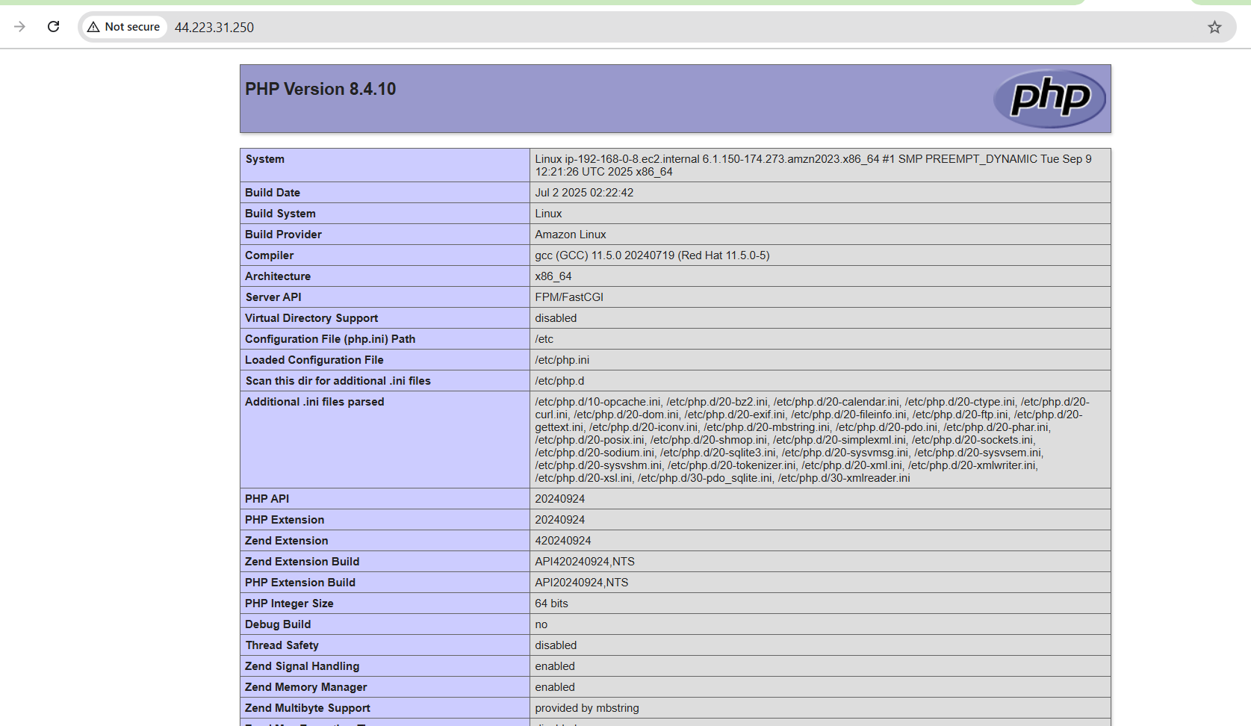

**8.Configure NAT gateway in public subnet and connect to private instance.**

* 1. Go to VPC service → NAT Gateways.
  2. Click Create NAT Gateway.

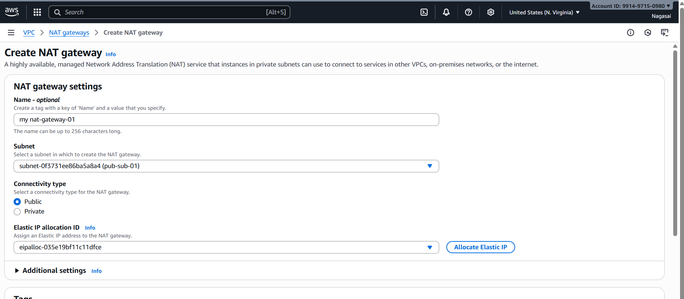

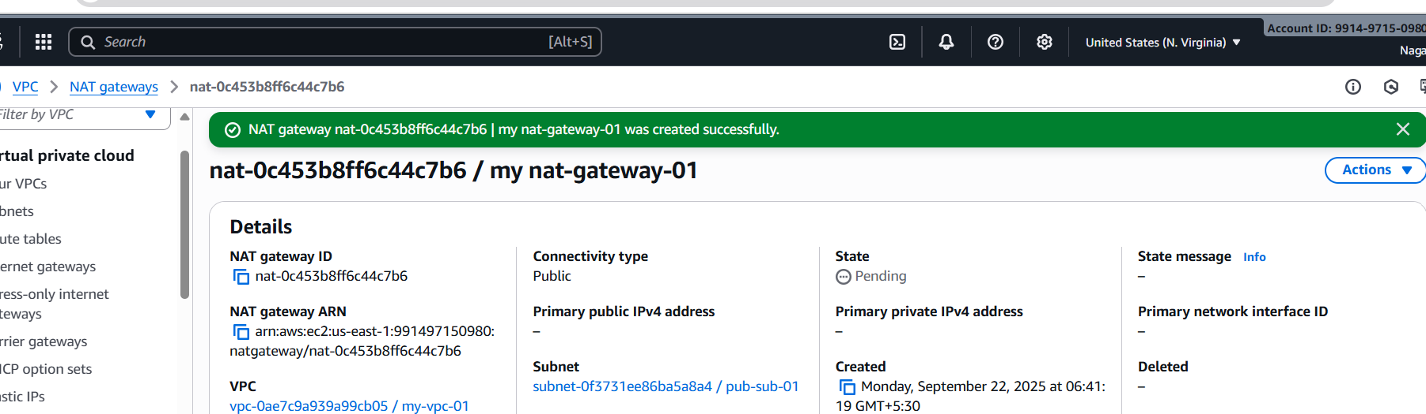

1. Go to Route Tables in VPC.
2. Select your Private Route Table.
3. Edit routes → Add new route:

Now, Private Subnets have internet access through NAT Gateway

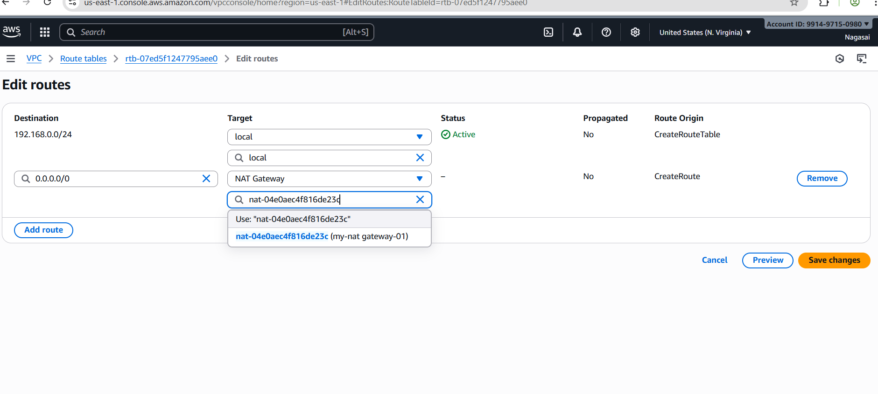

1. Launch an EC2 instance in **Private Subnet**.Security group: allow SSH only from your **Public EC2 (Bastion Host).**
2. SSH into **Public EC2** first:
3. ssh -i my-key.pem ec2-user@<public-ec2-public-ip>

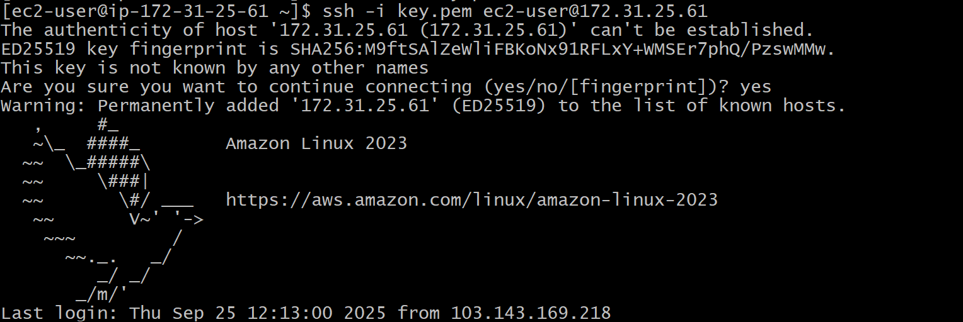

1. From inside Public EC2, SSH into Private EC2 (using private IP):
2. ssh ec2-user@10.0.3.25
3. From Private EC2, test internet:
4. ping google.com

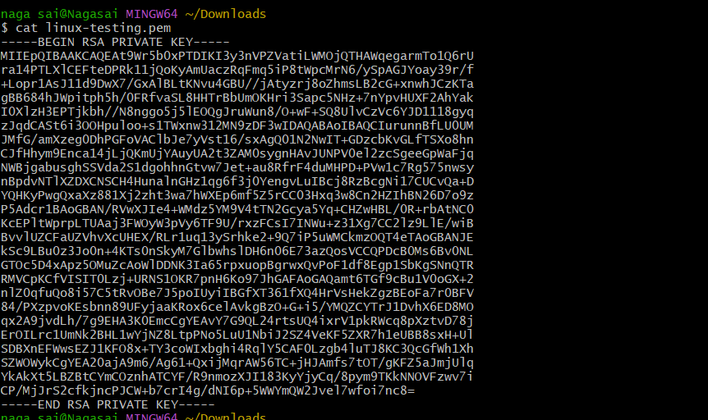

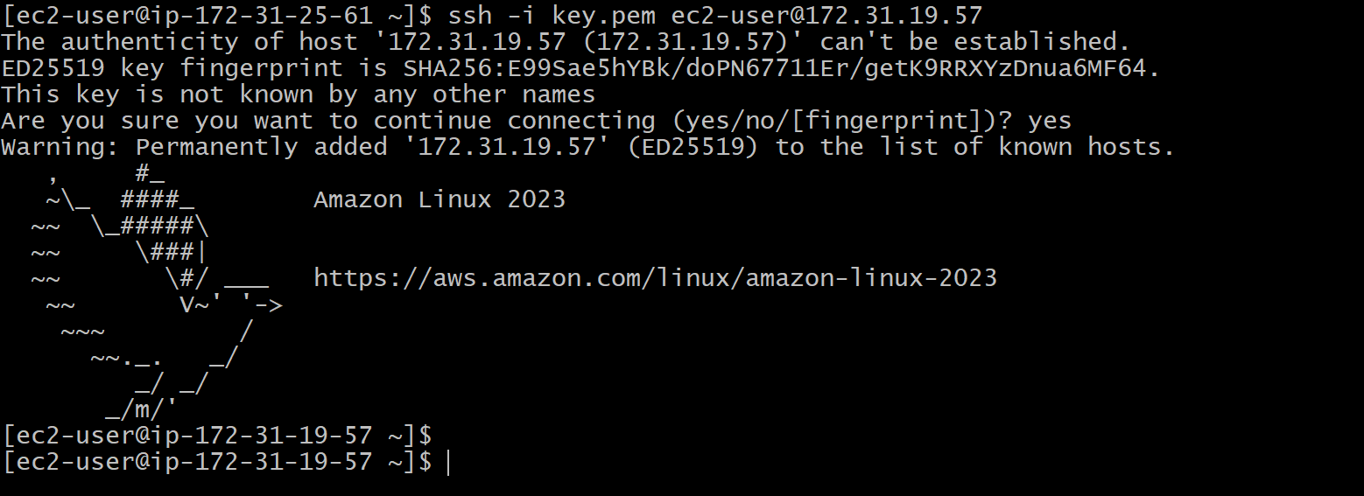

**9.Install Apache Tomcat in private EC2 and deploy a sample app.**

**Connect to Private EC2**

**Use the Public EC2 (bastion host) to SSH into the private EC2:**

**ssh -i my-key.pem ec2-user@<private-ec2-private-ip>**

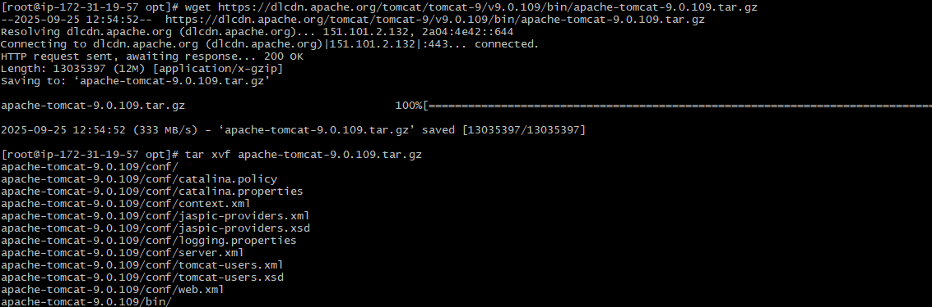

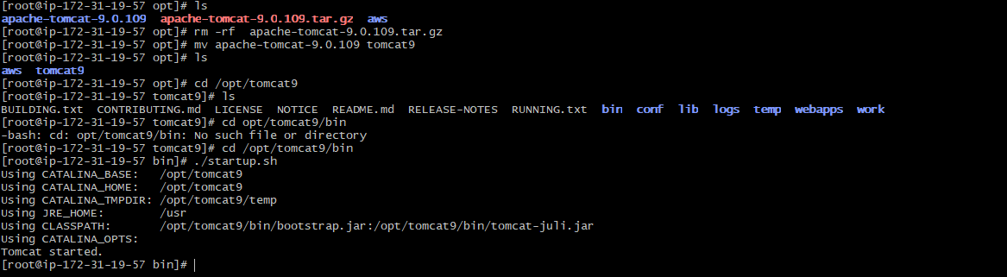

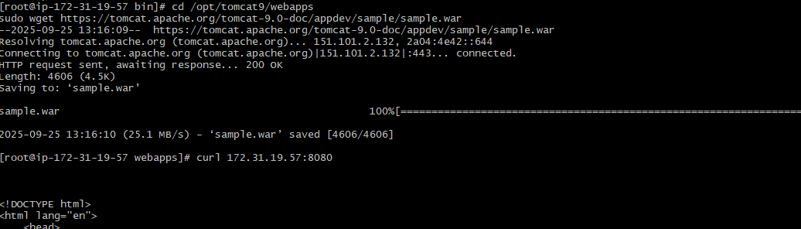

**10. Configure VPC flow logs and store the logs in S3 and CloudWatch**

We can store the logs in s3 bucket or cloudwatch.

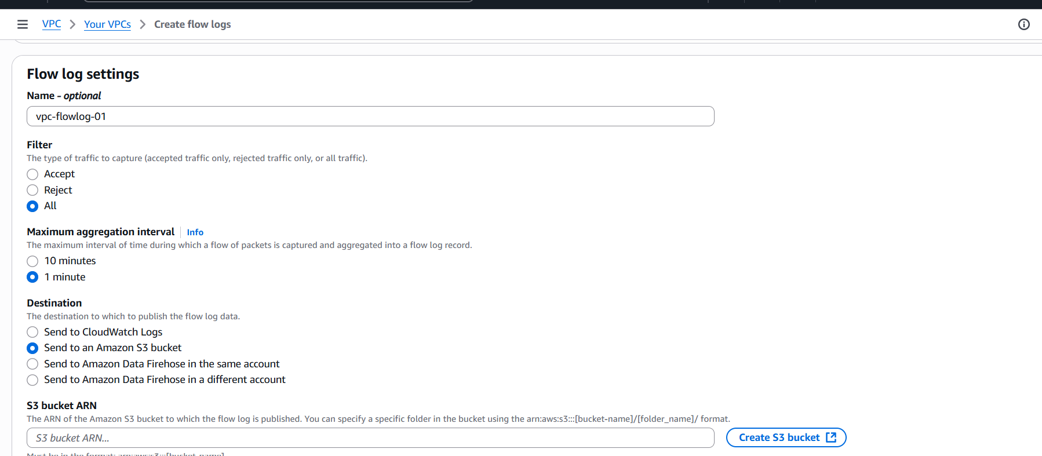

Go to services🡪search for s3 bucket and select general purpose and acl enabled and disable block all public access and also select log record format and click on create s3 bucket.

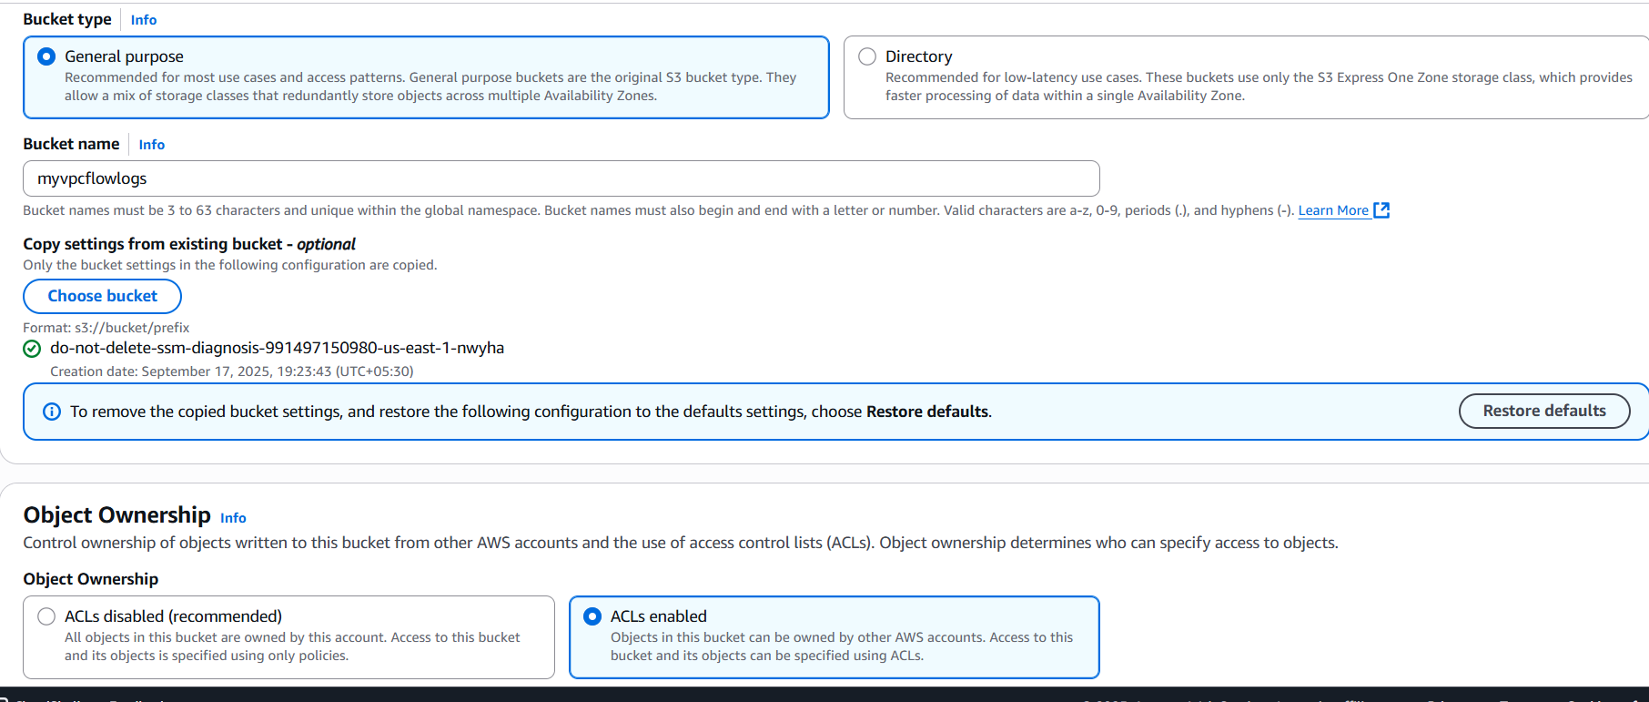

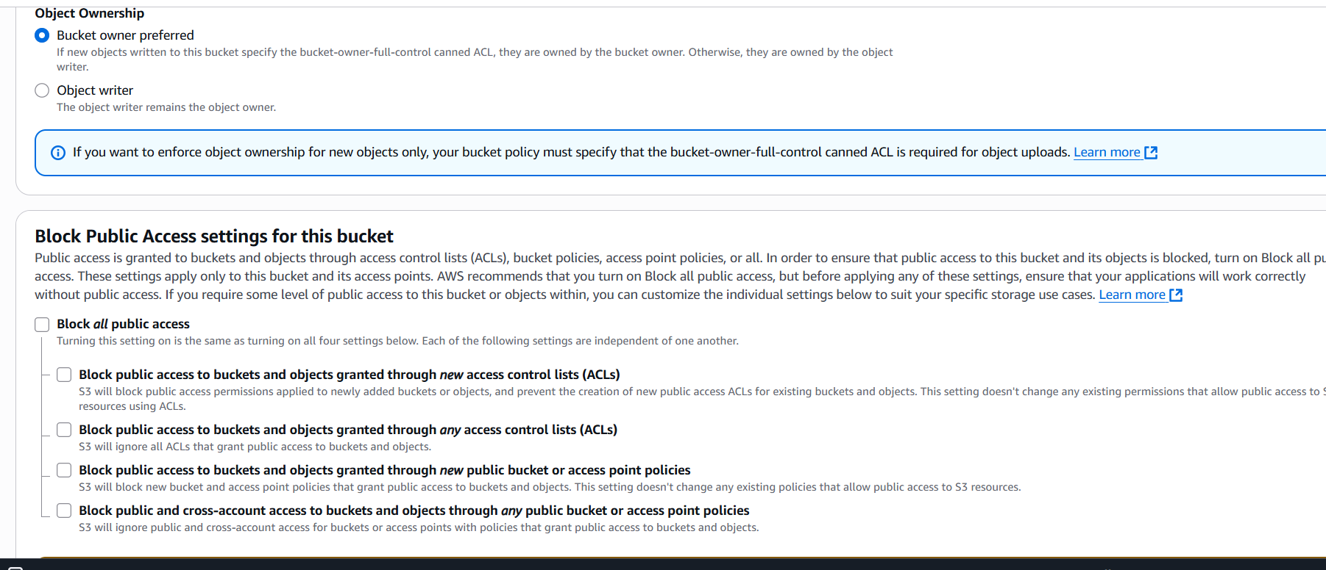

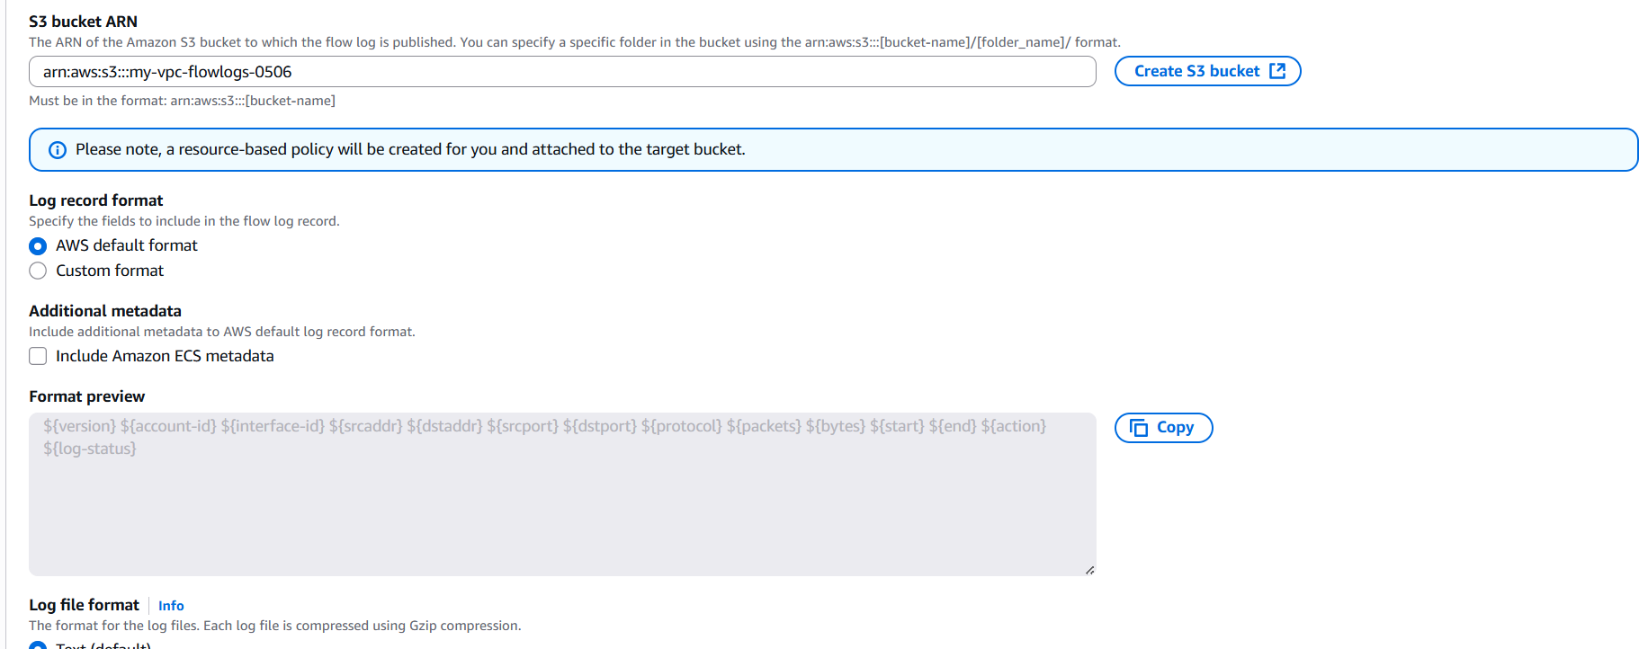

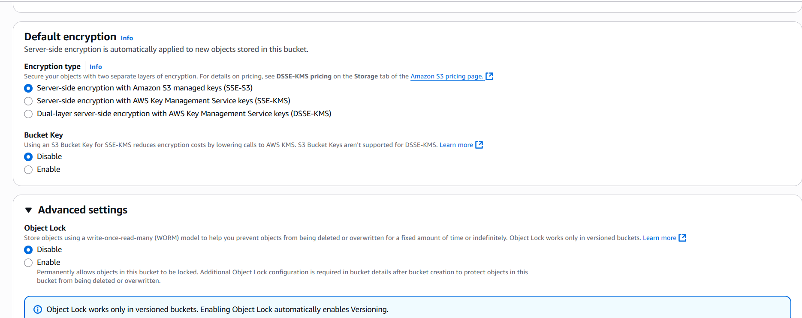

Then go to amazon s3 we can find that S3 bucket.



